\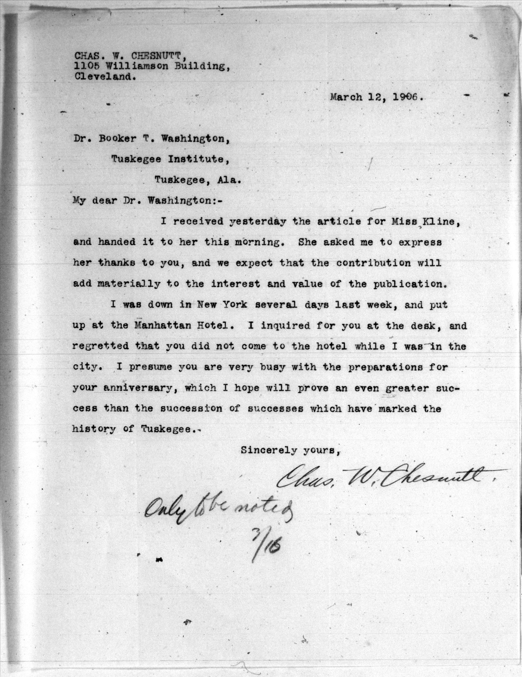
Contributor
Description,
Language
Date, Rights
Creator
Title

Title: | [Charles W. Chesnutt to Booker T. Washington, 12 March 1906] | Publisher:
Subject: |  | Contributor: | Booker T. Washington
Description: | A letter written by Charles W. Chesnutt to Booker T. Washington about an article that Washington sent to a Miss Kline through Chesnutt and detailing a trip Chesnutt took to New York where he had hoped to meet Washington. | Rights: | Item is in the public domain.
Type: | Letter | Date: | 12 March 1906
Source: |  | Format: | Print
Relation: |  | Identifier: | corr.00001
Coverage: |  | Language: | English
Creator: | Charles W. Chesnutt

