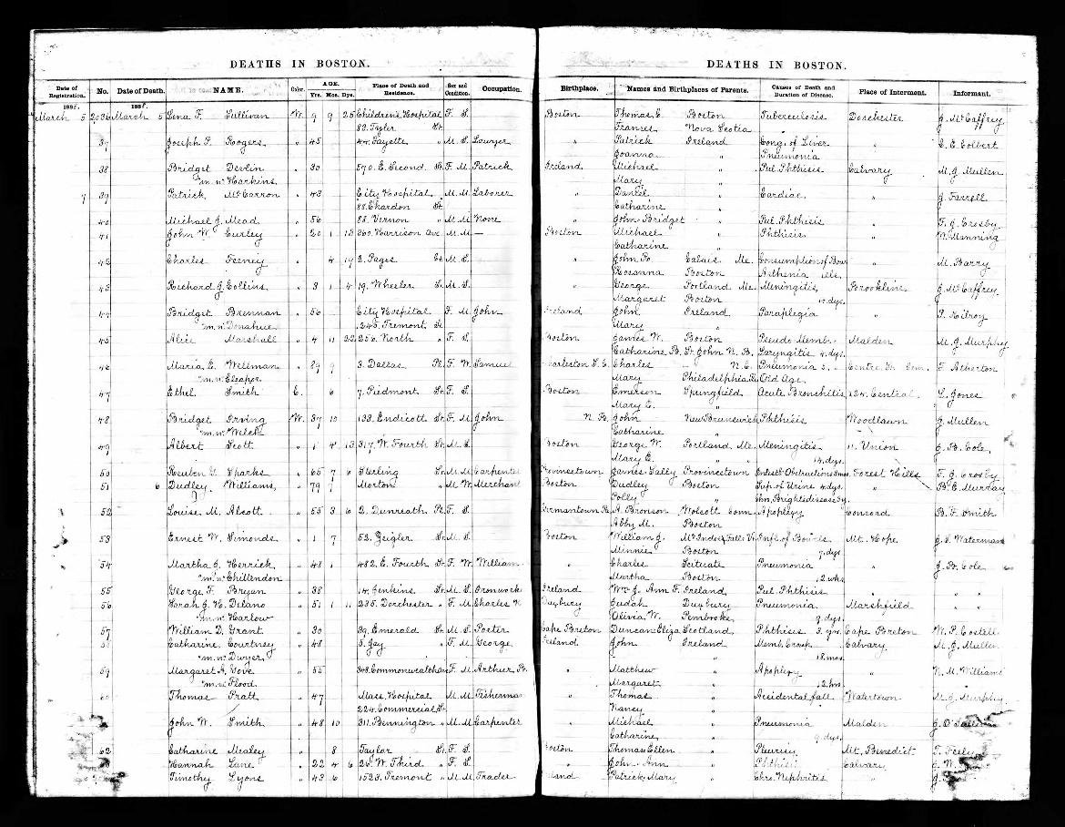

Pages that contain Louisa May Alcott’s death record

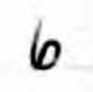
Date

Source
Fields in death records in which Alcott’s record was found

Coverage
Death record metadata from left page

Title, Description, Type, Language

Death record metadata from right page

Title: | [Death Record for Louia M. Alcott, 06 March 1888] | Publisher:
Subject: | Alcott, Louisa May, 1832-1888 | Contributor:
Description: | This death record for Louisa M. Alcott shows that she passed away at age 55 in Boston, Massachusetts of apoplexy in March 1888 and is buried in Concord, Massachusetts. | Rights: | Item is in the public domain
Type: | Death Record | Date: | 06 March 1888
Source: | Deaths in Boston | Format: | Print
Relation: |  | Identifier: | Index.death.001
Coverage: | Boston, Massachusetts | Language: | English
Creator:

