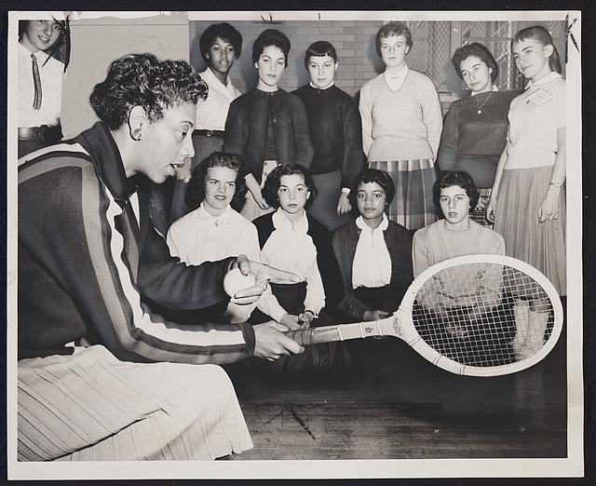
Title

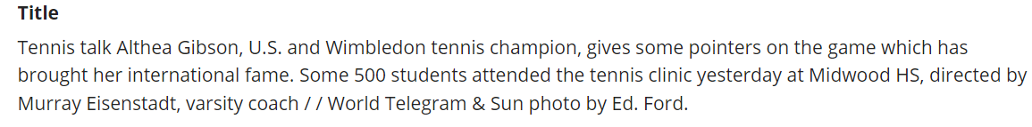

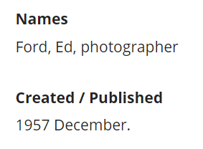
Subject, Description, Rights, Source
Date
Creator

Coverage

Title: | Tennis Talk | Publisher: | World Telegram &The Sun
Subject: | Tennis  Gibson, Althea, 1927-2003 | Contributor:
Description: | Althea Gibson gives a lesson to young women at a tennis clinic at Midwood High School. The clinic was directed by Murray Eisenstadt | Rights: | © World Telegram & Sun, 1957
Type: | Photograph | Date: | December 1957
Source: | World Telegram &The Sun | Format: | Print
Relation: |  | Identifier: | Img.001
Coverage: | New York | Language:
Creator: | Ford, Ed (photographer)

While we found this public domain image through the Library of Congress’s digital Free to Use and Reuse collections, we filled out the sample Dublin Core record above as if we were creating a record for a physical photograph that we were adding to a hypothetical question. For this reason, we used “print” for the Format element and “Photograph” for the type element. If we had known that the photograph we were creating metadata for was a film photograph, we might have made the Type element say “Photograph (Film).” The Format element could also be made more specific and included the dimensions of the photograph.
We chose the title “Tennis Talk” because it gives a general overview of what is happening in the photo. The description we chose is derived from the title, description, and summary on the Library of Congress’s record of the photo and gives a brief overview but also provides details about the photograph that might not be obvious just from looking at the photo. Looking at the back of a printed photo could provide more details if there is text written or printed on the back.
We listed the coverage here as New York, in part because the Library of Congress has the location set as New York. In this instance, we chose not to specify further. However, the description says that the photo was taken at Midwood High School; there is a Midwood High School in Brooklyn, New York City, New York. Depending on the item you are creating a metadata record for and the other records created for your collection, you may want or need to include more specific coverage information, such as a city.
Ed Ford was listed as the photographer of the photograph, and so we decided to list him as the author. We listed the publisher as World Telegram & The Sun since the photo was originally taken by Ford while reporting for the paper and they were responsible for publishing, printing, and distributing the original photograph before it became part of the Library of Congress Free to Use and Reuse Collections. We also included the paper as the source. However, if you were documenting the photo and it came from somewhere else—say, a book of photographs that were taken for the paper—that might be listed as the source. There would also be the option of leaving this field blank if there wasn’t a source or if you had just the photograph and didn’t know what paper it came from.
The Library of Congress has a collection of photographs in their Free to Use and Reuse Collection, meaning that the photos in the collection are believed to be in the public domain or believed to not have copyright restrictions or that they’ve received permission from the copyright owner to be included in the collection. Essentially, the photos in the collection are likely okay to use as if there were little to no copyright restrictions on them. In this case, because the photo is dated as being taken in 1957 and because as of 2024 everything in 1928 or earlier is in the public domain, the Library of Congress most likely got permission from the copyright holder to include this photo in their collections. That being said, this is not a common occurrence for items that are still within the timeframe designated by copyright. Because we filled out this record as if we were creating a digital record for a print photograph, it was created in 1957, and because it is likely that most of the items that you might create records are going to be in copyright, we included the copyright holder. If you knew that because of the date the item was in copyright but you weren’t sure who held the rights, you could create a blanket statement that says while you aren’t sure who holds the copyright, you believe that the item is in copyright and that it is up to the user to research rights information. For example, the University of Iowa’s Special Collections and Archives uses variations of the statement: “Copyright restrictions may apply; please consult Special Collections staff for further information.” Statements may also indicate that the patron is responsible for researching and knowing rights information about a record or item.
The photo was listed as being taken in December of 1957, which we listed as the date. It’s possible that if we were creating a photo and were creating a record for the photo as it appeared copied in the newspaper—rather than the original printed image itself—we might use the coordinating article to deduce the date that the photograph was taken or use the publication date for that issue of the newspaper.
We created the identifier as “img.0001” to indicate that the format of the item was an image, and the number 1 to indicate the number of images that we might have processed in our hypothetical, larger, collection.
While we did not include a language for this specific record, we have included a language or languages if there was metadata about the photograph written on the opposite side of the photograph and/or if there was text contained in the image itself.

