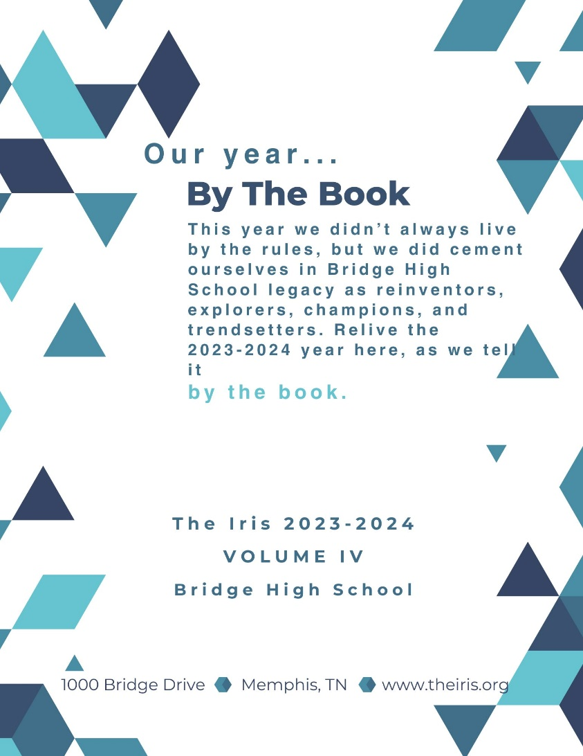

Subject, Description, Type, Language

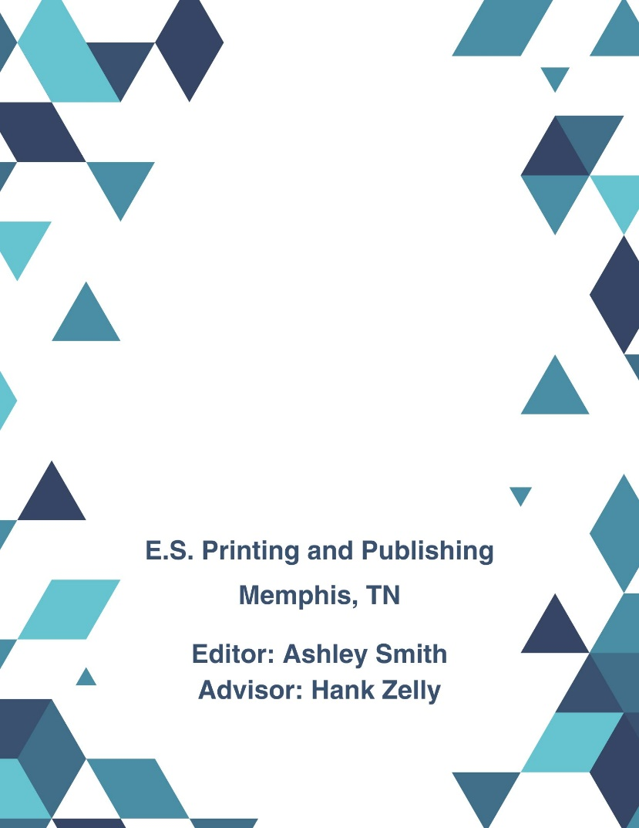

Title
Coverage

Creator
Special thanks to The Iris 2023-2024 staff for their hard work on this year’s book!

© 2024 Bridge High School
Publisher

Contributor

Title: | The Iris, 2023-2024 (vol. IV) | Publisher: | E.S. Printing and Publishing Company
Subject: | Bridge High School (Memphis, TN)  High School Yearbooks | Contributor: | Ashley Smith (Editor)  Hank Zelly (Advisor)
Description: | This is the 2023-2024 edition of The Iris, the yearbook for Bridge High School in Memphis, Tennessee. | Rights: | © Bridge High School
Type: | Yearbook | Date: | 2024
Source: |  | Format: | Print
Relation: |  | Identifier: | ybk.iris.iv
Coverage: | Memphis, Tennessee  August 2023 – May 2024 | Language: | English
Creator: | The Iris 2023-2024 Staff

We created this record as if we were creating a digital record for a physical printed yearbook.
The title element was created with the same title that is on the title page.
While the subject terms included in the subject element are not a part of an authority file, we included them because they might be helpful for patrons doing research about the high school or yearbooks in the region.
The description was created from the title and copyright pages displayed in the graphic, summarizing some of the key information about the item—including that it is a yearbook, what high school, where the high school is located, the name of the yearbook, and the years that the yearbook contains.
We recorded the type element as yearbook to indicate a more specific format and genre of a printed text.
We included two values in the coverage element to indicate both the spatial and temporal coverage of the yearbook. The high school is located in Memphis, Tennessee. We chose August 2023 – May 2024 as a more specific coverage because that is the timeframe for the school year.
Currently, many high school yearbooks are created by a staff of student volunteers. Staff can range in size and many people contribute to just some of the pages but now. This is why we decided to indicate collective authorship in the creator element. If you felt it was important for your record to list every student contributor, their names tend to be listed somewhere in the book.
However, we decided to include Ashley Smith and Hank Zelly as contributors because their names are specifically indicated as editor and advisor positions on the copyright page of the book. Their titles indicate that they played a significant role and likely held more responsibility in the overall production of the book without being the sole creator of the entire book; collective authorship in the creator element also implies their names and contributor allows them to be recognized for their responsibility as editor and advisor.
Though the staff authored the yearbook, there was a separate company responsible for the printing and publishing of a book. The publisher was listed as E.S. Printing and Publishing Company and was indicated as such in the publisher element.
The rights belong to the school, who likely helped fund the production of the yearbook. The yearbook is also a record for the school as a whole and is more likely to hold the copyright to the book rather than the staff, club, or each of its individual measures, though it is important to look throughout the book for possible rights information.
Because the coverage of the book is the 2023-2024 school year, the date that the yearbook was finished being created, was printed, was published, and was distributed is the end of the school year—spring 2024. This date here was meant to indicate completion; it’s possible that you might want to include the school year range here as well.
We chose the identifier element to be “ybk.iris.iv” to indicate that the item was a yearbook, that it was The Iris, and that it was the fourth volume of that particular yearbook.
The language for the entirety of the yearbook was English. If there are multiple languages you may want to consider listing more than one language for this element.

